Functional Specification
Document Name: FS-Process Step-Name of the Title for this FS document
Process Step: Process Step, Name of Process Step
Title: Name of the Title for this FS document
Approval

Change History
All italic and blue text in this document is for descriptive purposes only.
Note by: before finishing and storing the document all reference field in the document should be updated and refreshed. This can be done individually by navigation to the reference field and pressing key “F9” or by selecting the page preview functionality and switching back to normal edit mode. The table of contents has to be updated individually itself and will not be effected by the page preview mode.

Version | Author | Description of Change
01 | Ingo Kaulbach  (EVFPU) | Initial Creation, ZHHR:
Table of Contents
1 Overview 4
2 Scope Description 4
3 Terms and Definitions 4
4 Cross References 4
5 Functional Realization Statements 5
5.1 Reference to Configuration Documents / Customizing Objects 18
6 Attachments 19
7 Further Information 19

Overview
Please provide an overview of the functional realization of the user requirements from the URS. Briefly summarize the overall functional realization of the process step in SAP.
The Menu Path column could be left empty when such a menu path is not available
Also this information should be given in free text form below the table:

This is a Functional Description for process-step - .
SAP Easy access menu to the main transactions is been described in the following table:
Menu Path | Transaction Code
N/A | N/A

Scope Description
The scope is the same as defined in the URS document, so only a reference is given.
It defines the applicable specification from a global or local point of view.

For the description of the scope please see the URS related to this process step:
URS-- UPDATE WHEN KNOWN

Terms and Definitions
Please make sure, that all terms, definitions, abbreviations and acronyms that may be helpful for understanding this document are listed. You may add some very specific terms and definitions to the table below. Otherwise please fill in “N/A”.

Term | Definition
N/A | N/A

Cross References
Please list all related process steps, Customizing Objects and other Functional Specifications
- Only list Business Processes / Process Steps where this FS is explicitly referenced in a realization statement in the FS for that process step. Do NOT list process steps which are just loosely connected to this development
- Also list other developments which may be related to this document.

Related Business / Process Steps | N/A
Related Functional Specifications | N/A
Related Design Specifications | DS-Doc41 Web UI.doc

Functional Realization Statements
Please translate each user requirement statement from the URS into functional realization statements in the table below. Please therefore indicate the corresponding requirement number from the URS and the type of realization (S, C, D, A, SOP, M, N.).
- For traceability reasons every realization statement must get a unique ID (column “Realization ID”). Naming convention: XX_XX_XX_FS_NNN
  - XX_XX_XX: ID of the Process Step, e.g. M-220-010
  - NNN: up counting number of the realization statement
- The requirement IDs could be referenced in an abbreviated manner (column “Requirement ID”), e.g. as GR_001, if they refer to the same process step Process Step
- Please use one line for one realization statement
- The type of realization defines in short how the requirement is realized (column “Type”):
  - S: The requirement is realized by SAP standard, no customizing or whatsoever required (Transaction Codes must be filled in column “Realization Statement”).
  - C: Customizing is necessary (Transaction Codes and Customizing Objects must be filled in column “Realization Statement”). Realized by a custom made development (Customizing Objects and references to Design Specification must be filled in column “Realization Statement”).
  - A: Realized by the Authorization Setup
  - SOP: not technically realized, instead a procedure is created
  - M: the requirement can be fulfilled by master data maintenance.
  - N: not realized at all.
- If one realization statement covers more than one requirement, list them all in the same line
- It is possible to spread the realization of one user requirement over several lines (so several realization statements)
In case additional functional requirements will be derived from the risk analysis, please add those to the table in the same manner as the user requirements.
It is recommended to fill in the statements with short sentences rather than long descriptions. All statements should be expressed in a clear, unambiguous and measurable way so that test acceptance criteria can be derived later on.

The requirements listed in the column “Requirement ID” are always referring to any relevant URS document (if not explicitly stated otherwise). So a requirement “GR_001” must be read as “_GR_001”.
Realization ID |  |  | Requirement ID | Type¹⁾ | Realization Statement
XX_XX_XX_FS_001 |  |  | (XX_XX_XX_)GR_001 |  | User Management  The User Management must contain following functions:  - Create user  - Delete user  - Change user data  - Add role to user  - Permission check  - New password for external user  - Connection to WebSEAL  - Connection to LDAP  Create user  Create internal user  Search user in internal LDAP and get user information.  Import user into Doc41WebUI database.  Set Doc41WebUI group in LDAP.  Create external user  Enter user information.  Store user into Doc41WebUI database.  Set Doc41WebUI group in DMZ-LDAP.  Delete user  Delete user logical in database.  Remove Doc41WebUI group in LDAP.  Change user data  Display user information.  Enter changed user data.  Save changed data in database.  Add role to user  Add role  Add role to user and store into database.  If first role: Set Doc41WebUI group in LDAP for internal user or DMZ-LDAP for external user.  Remove role  Remove role from user and store into database.  If this was the last role: Remove Doc41WebUI group in LDAP for internal user or DMZ-LDAP for external user.  Permission check  Only users with role Business Admin or Technical Admin are allowed to see and use the user management.  New password for external user  The administrator must be able to set a new password for external users.  Connection to WebSEAL  Only active users are allowed to enter Doc41WebUI. WebSEAL ensures authentification and authorization via LDAP.  Workflow User Management  Create internal user  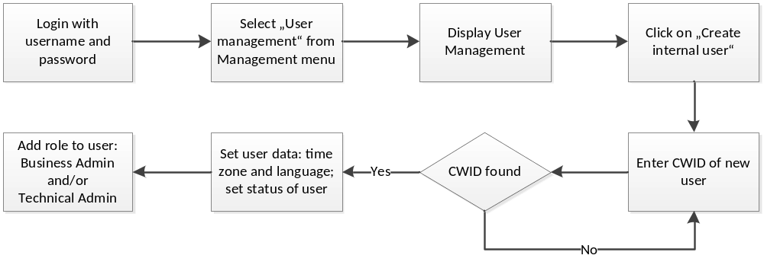  The administrator has to log in with his user name and password.  The administrator has to select „User management“ from management menu and the user management page displays.  The administrator has to click on “Create internal user” to create a new internal user.  The administrator has to enter the CWID of the new user and if the CWID can be found in Bayer-People-Directory the administrator can set time zone and language of the user. He also has to set the status of the user. Only active users can log into Doc41WebUI.  The administrator can give the internal user one or more of the roles:  - Business Admin  - Technical Admin  Create external user  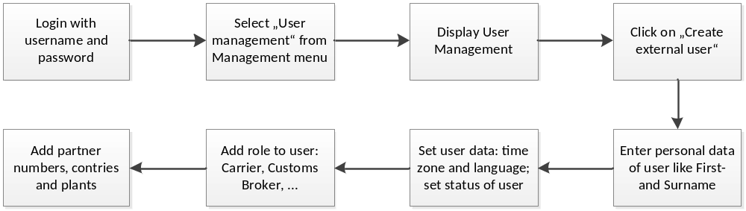  The administrator has to log in with his user name and password.  The administrator has to select „User management“ from management menu and the user management page displays.  The administrator has to click on “Create external user” to create a new external user.  The administrator has to enter the personal data of the user, like First- and Surname. The administrator can set time zone and language of the user. He also has to set the status of the user. Only active users can log into Doc41WebUI.  The administrator can give the external user one or more of the roles:  - Carrier  - Customs Broker  - Material Supplier  - Product Supplier  - ViewerCountry  - ViewerCustomer  - Layout Supplier  - PM supplier  Change internal user data  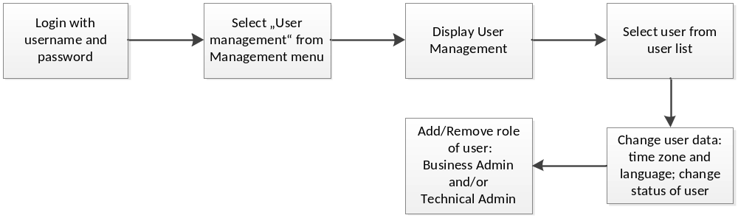  The administrator has to log in with his user name and password.  The administrator has to select „User management“ from management menu and the user management page displays.  The administrator has to select an internal user from user list.  The administrator can set time zone and language of the user. He also has to set the status of the user. Only active users can log into Doc41WebUI.  The administrator can add or remove roles of the internal user:  - Business Admin  - Technical Admin  Change external user data  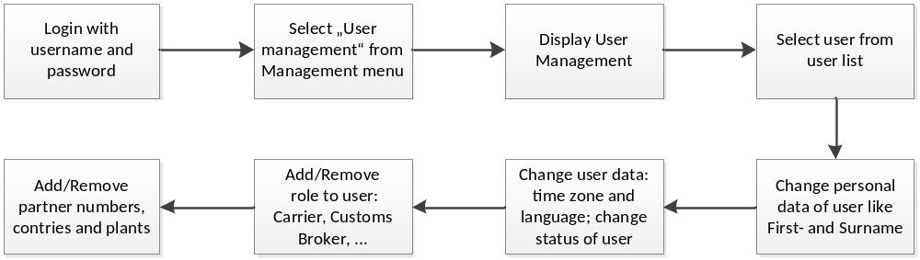  The administrator has to log in with his user name and password.  The administrator has to select „User management“ from management menu and the user management page displays.  The administrator has to select an external user from user list.  The administrator has to change the personal data of the user, like First- and Surname. The administrator can set time zone and language of the user. He also has to set the status of the user. Only active users can log into Doc41WebUI.  The administrator can add or remove roles of the external user:  - Carrier  - Customs Broker  - Material Supplier  - Product Supplier  - ViewerCountry  - ViewerCustomer  - Layout Supplier  - PM supplier  New password for external user  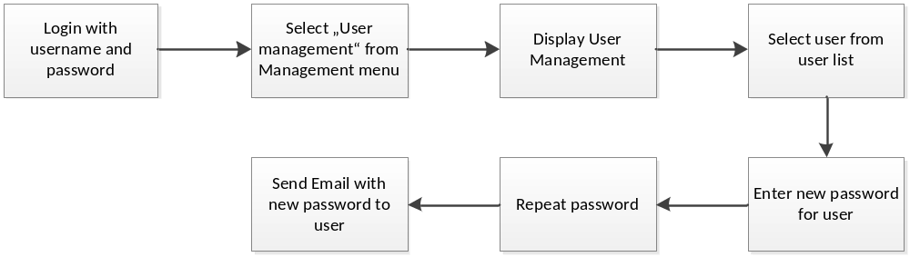  The administrator has to log in with his user name and password.  The administrator has to select „User management“ from management menu and the user management page displays.  The administrator has to select an external user from user list.  The administrator has to enter and repeat a new password for the user.  The system will send the new password to the user via email.

Technical Admin
Technical Admin can use maintenance menu which contains:
- Support Console
- Translations
- Interface Monitoring
- Profile Permissions View

Business Admin
Business Admin can use Management menu which contains:
- User management
XX_XX_XX_FS_002 |  |  | (XX_XX_XX_)GR_002 |  | The Doc41 Web UI core system has to provide RFCs for document download and document upload.  Document search should be implemented as a RFC in BW. The output of this RFC has to be functionally identical to the Doc41 core document search RFC.
1) | S | Requirement is covered by SAP standard
 | C | Requirement can be covered by system parameterization / customizing
 | D | Requirement can be covered by customer-specific development
 | A | Requirement can be covered by authorization management
 | SOP | Requirement can not be covered by the system. Therefore an SOP is needed
 | M | Requirement can be covered by master data maintenance
 | N | Requirement will not be realized

Reference to Configuration Documents / Customizing Objects
It is recommended to fill in the corresponding customizing objects in the following table.

IMG Customizing Objects | IMG Object Text | Type²⁾ of Customizing Object (V/C/T)
N/A

2) | C | Viewcluster
 | L | Logical transport object
 | S | Table (with text table)
 | T | Individual transaction object
 | V | View
 | D | Dummy object

Attachments
Please list here all attachments to this document. Fill in N/A if the document has no attachments

N/A

Further Information
Please use this section to add information that does not fit in any of the other sections. Use it especially to add complex details (e.g. tables) which do not have enough room in the functional realization table.
Do NOT put information in here, which will be already covered in further documentation as the Design Specification for Developments or the Configuration Documents.
Fill in N/A if the document has no further information.

N/A

